**Pizza Sales Queries**

KPI’S

**1 Total Revenue**

**select round(sum(total_price),2) as Total_Revenue from pizza_sales1;**

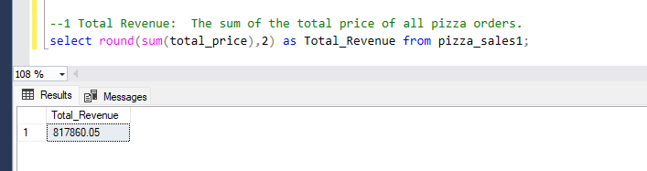

**2 Average Order Value**

**Select convert(decimal(10,2),sum(total_price)/count(distinct order_id)) as Average_Order_Value from pizza_sales1;**

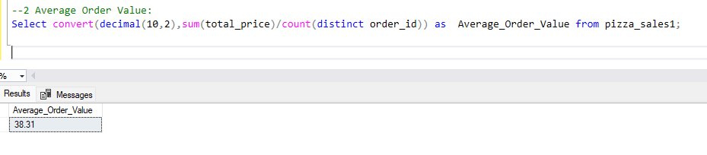

**3 Total Pizzas Sold**

**Select sum(quantity) as Total_Pizza_Sold from pizza_sales1;**

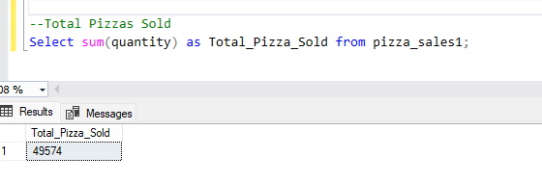

**4 Total Orders**

**Select count(distinct order_id) as Total_Orders from pizza_sales1;**

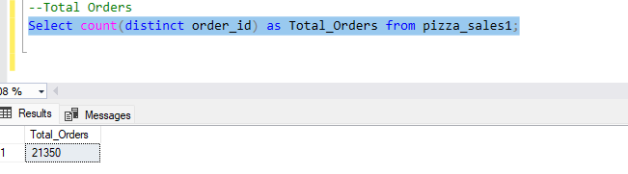

**5 Average Pizzas Per Order**

**Select sum(quantity)/ count(distinct order_id) as Average_pizza_Per_order from pizza_sales1;**

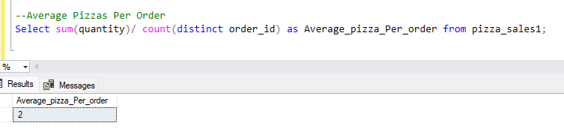

**1.Daily Trend for total orders**

**select DATENAME(weekday, order_date) as Week_Name, count(order_id) as Total_Orders from pizza_sales1 group by DATENAME(weekday,order_date) order by Total_Orders desc;**

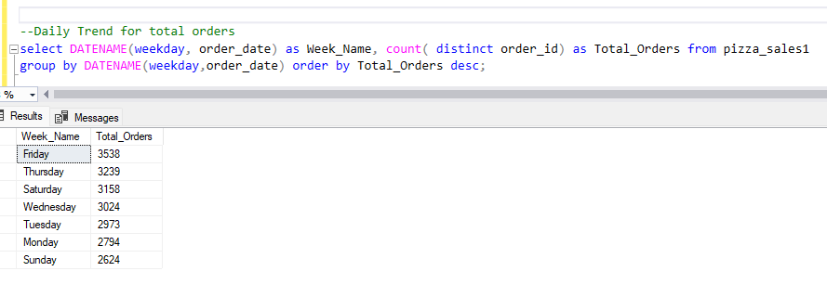

**2. Hourly Trend for Total Orders:**

**select datepart(hour,order_time) as orders_Hour, count(order_id) as order_count from [dbo].[pizza_sales1]**

**group by datepart(hour,order_time) order by order_count desc;**

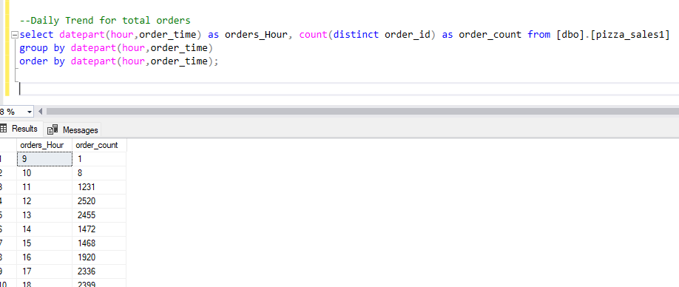

**3. Percentage of sales by Pizza Size:**

**select datepart(hour,order_time) as orders_Hour, count(distinct order_id) as order_count from [dbo].[pizza_sales1]**

**group by datepart(hour,order_time)**

**order by datepart(hour,order_time);**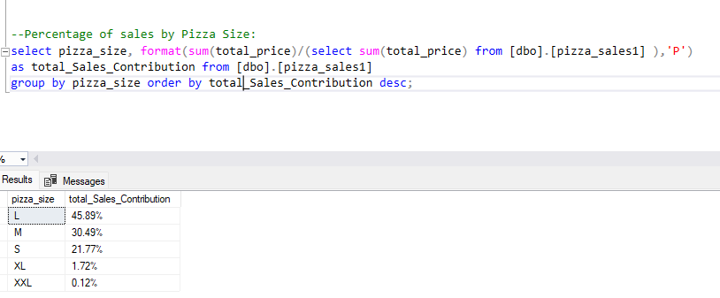

**4. Total Pizzas Sold by Pizza Category**

**select pizza_category,sum(quantity) as total_sold_pizza from [dbo].[pizza_sales1]**

**group by pizza_category order by total_sold_pizza desc;**

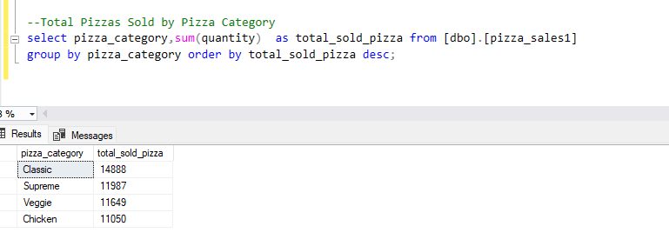

**5. Top 5 Best sellers by Total Pizzas Sold:**

**select top(5) pizza_name, sum(quantity) as total_sold_pizza from [dbo].[pizza_sales1]**

**group by pizza_name order by total_sold_pizza desc;**

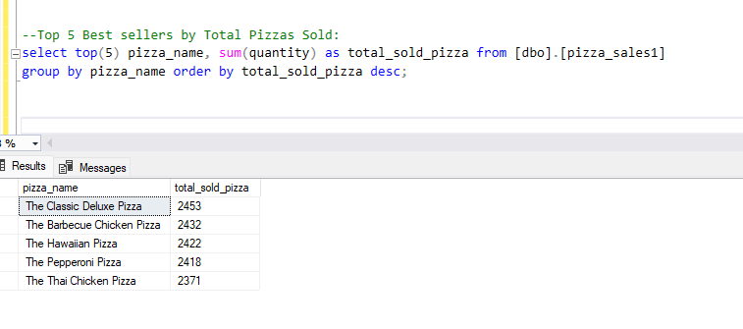

**6. Bottom 5 Worst Sellers by Total Pizza Sold:**

**select top(5) pizza_name, sum(quantity) as total_sold_pizza from [dbo].[pizza_sales1]**

**group by pizza_name order by total_sold_pizza;**

